# **Release notes – 04.09.2022**

We are pleased to announce about new features that we’ve added to the GreenRoad DRIVE™ mobile app (Version 7.0.0)

* Drivers Duty mode in Live fleet
* Notification about miss configuration in Dashboard
* Safe Journey solution adjustments

Below is a more detailed explanation of each of these features.

**Drivers’ Duty mode:** is now available in Live fleet

Live fleet view in Drive app is the best place to look for a location of the driver or find drivers in specific locations. **Starting now, you can know what us the actual duty mode** of your drivers

Now, in live map

when you tap on the  icon you will get the list of all drivers shown on the map with their current duty status.

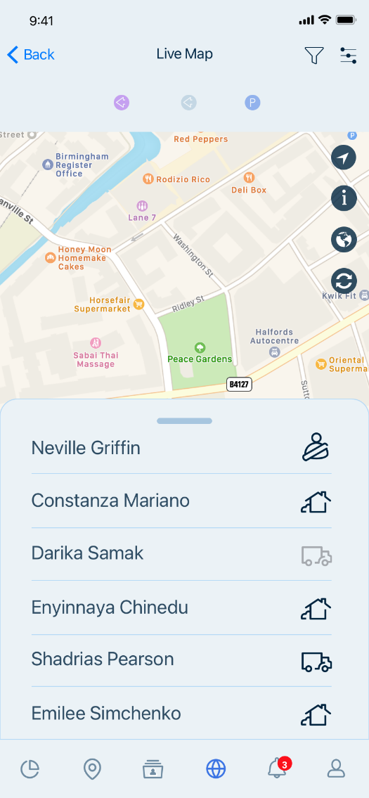

Driver shown with  icon is a driver that currently is in On Duty Mode

Driver shown with  icon is a driver that currently is in Passenger Duty Mode

Driver shown with  icon is a driver that currently is in Off Duty Mode

Driver shown with  icon is a driver that currently is in Personal Duty Mode and the location in which he shown on the Live map is the last location in which he was On Duty.

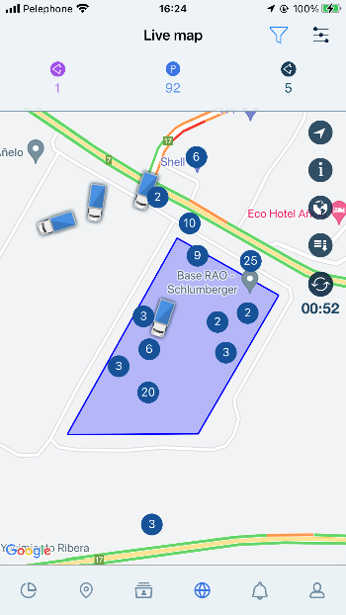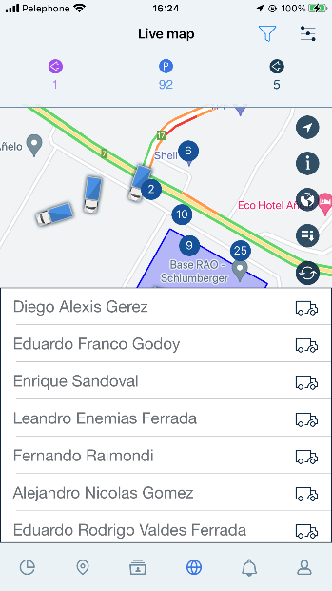You can search for a specific driver or Landmark in one of our search filters options in the app and see the driver’s duty status in those location in 3 clicks.

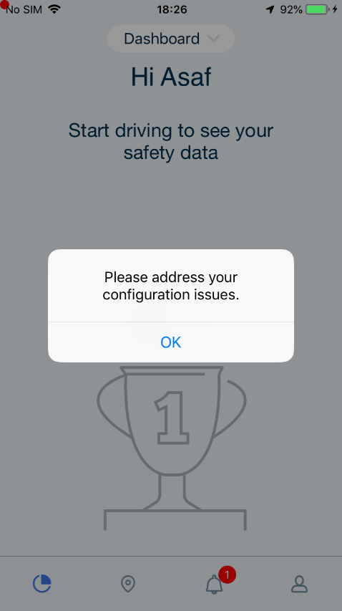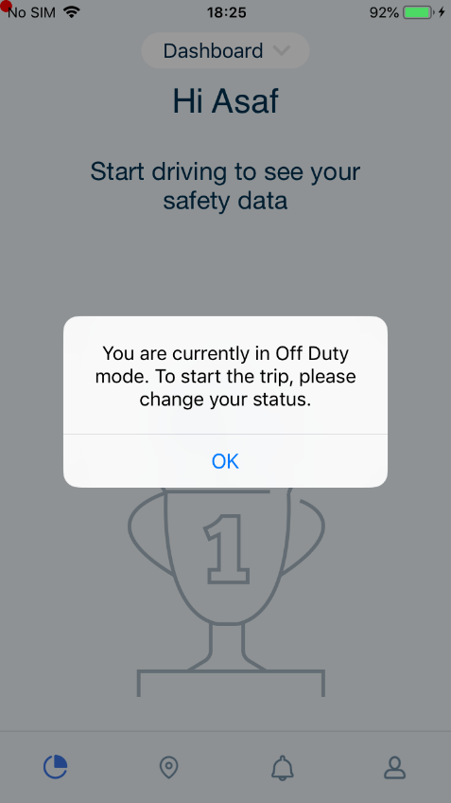**Notification about miss configuration** is added to the dashboard.

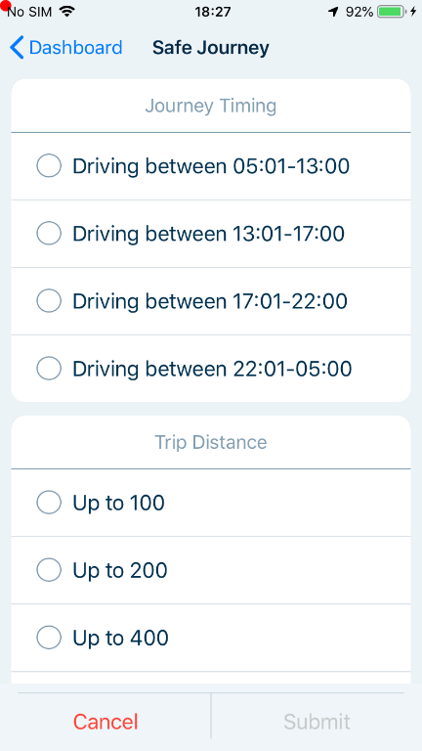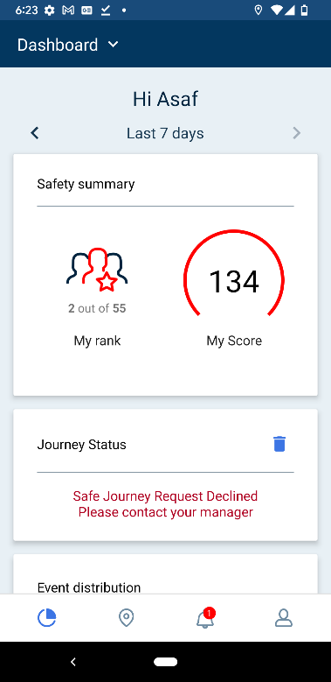**Safe Journey solution** is updated

We’d love to hear your feedback about these or any GreenRoad features. Here’s to safe journeys!

The GreenRoad Development Team