**Product Release Notes**

Dear GreenRoad Customer,

We are pleased to share the new features included in the latest release of GreenRoad Central.

* Report Settings Adjustment
* Engine type filter on Live view
* Personal ID field is no longer mandatory

# Report Settings Adjustment

To improve system performance, we’ve adjusted default settings in the following Reports:

* Location history
* Stops Log
* Idling event log
* Deleted Idling Events Log

**New Default Settings:** The report now defaults to showing “Latitude” and “Longitude” columns instead of the “Address” column.

If necessary, you can add the Address column by selecting “Customize Columns.”

This update will **not** impact any reports you have already scheduled; it will only apply to new reports you set up.

If your report requires address information, you can easily add it by following these steps:

1. Click on the “Customize Columns” button.



1. Select the Address column and click “Done.”

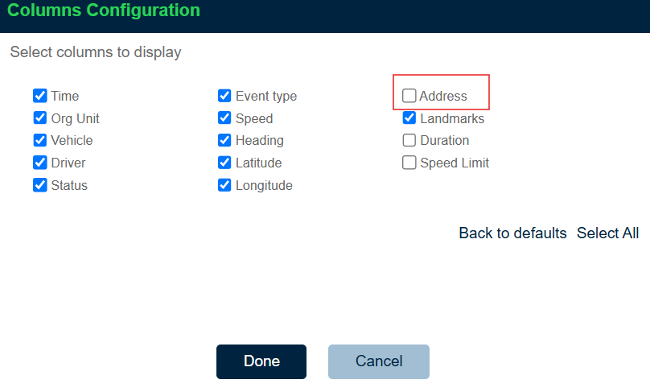

This adjustment is part of our ongoing efforts to optimize reporting performance. The Address column places a significant load on the system, so if address information isn’t essential, we encourage you to use the default “Latitude” and “Longitude” columns.

# Engine type filter on Live view

The **Engine Type Filter** allows you to filter vehicles by the engine type in the Live View map. This feature enables you to quickly locate and monitor vehicles based on the engine type, improving operational efficiency and fleet oversight.

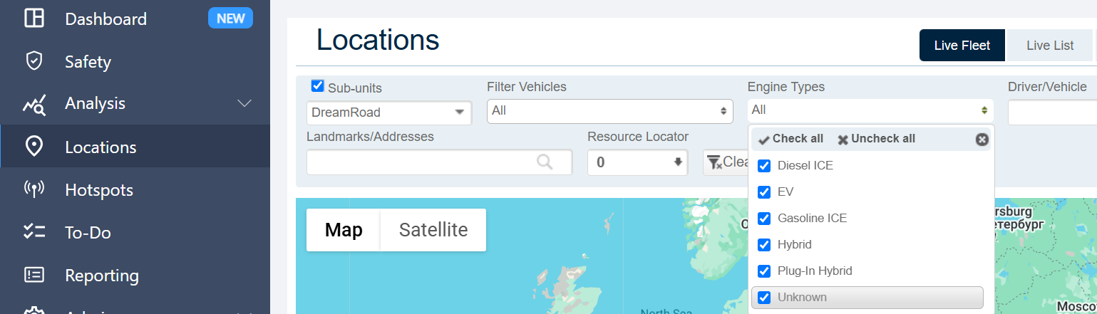

# Personal ID field is no longer mandatory

The **Personal ID** field is now optional for all users. This change allows greater flexibility when adding or updating user profiles without requiring a Personal ID.

Thank you for choosing GreenRoad!   
We look forward to supporting your journey towards safer and more efficient driving.  
  
Please feel free to reach out with any questions at [productcentral@greenroad.com](mailto:productcentral@greenroad.com )